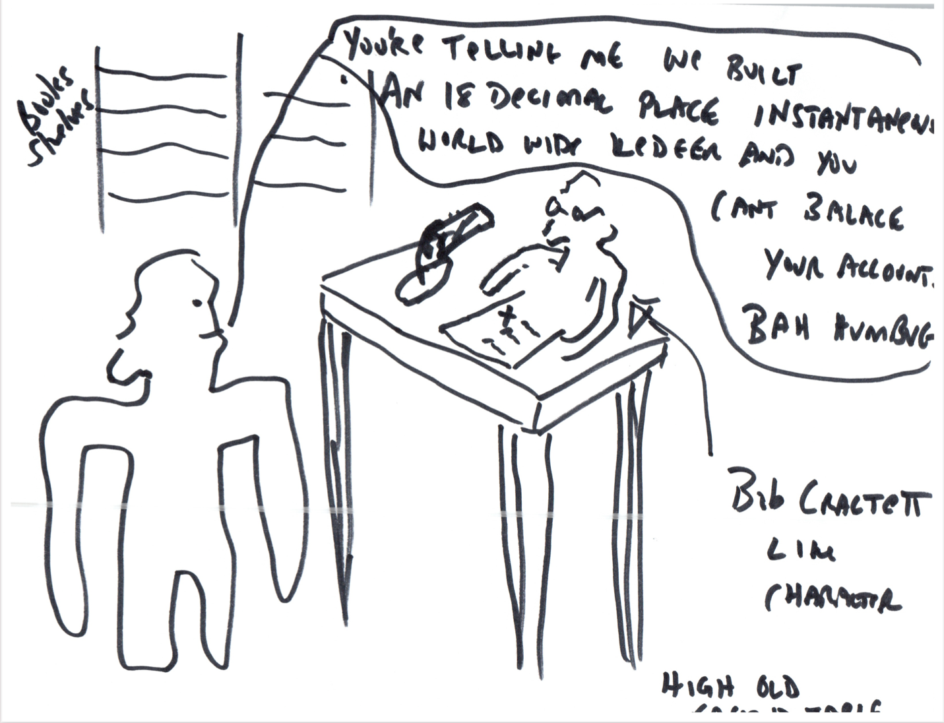

The idea here is to play off the idea that prior to computers people had built up very vast financial / business structures that, while they may not have been able to scale worldwide, could account for every penny. The story of Ebenezer Scrooge in Charles Dicken Christmas carol is an example of a penny pincher. Someone who cares about every penny.

One of the dreams of crypto currencies that I fell in love with was the fact that we now, for the first time in human history, have an 18-decimal place accurate accounting system that comes to reconciliation every 14 seconds (in the case of Ethereum – for Bitcoin, it takes ten minutes).

The amazing thing to me is, and anyone who actually knows anything at all about Ethereum can attest to this, is that it is LITERALLY impossible to balance one’s accounts. An individual person simple cannot get enough information from this worldwide, shared global ledger to make any sense of what’s happening.

There’s a number of aspects to the total shortcoming of the system (I’ve played off this idea in other images).

I this image I’m trying to play off the idea of a penny pincher being amazed to discover that the “perfect accounting system” is anything but perfect.

The image (copied again so I can see it) is internal to a small London shop in the 1850s?. Ebenezer is standing next to a high- “scrihvner’s” desk (I just made up that word). A sort of high table. A Bob Crachett like “clark” is sitting with a curious/confused look at a computer (that looks like paper?) He clearly can’t figure something out.



There may be dusty bookshelves in the background.

Scrooge says something like “You’re telling me we built an 18-decimal place, continually reconciled accounting system and you can’t tell me how many tokens I own?” And then I want him to also say “Bah Humbug.”

There may be a candle or a bankers lamp on his desk.